PART IIA:Logical Model – Relational Model

1.a. Strong Entity With a Composite Attribute

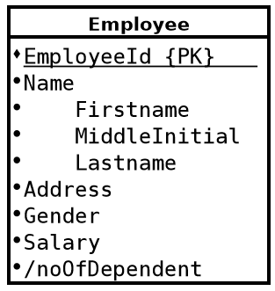

Employee
EmployeeId | FirstName | MiddleInitial | LastName | address | gender | Salary | noOfDependent

Cont. Employs 1..*
SupervisorId | Factory_Id
F.K.

For the composite attribute you make each of the parts into its own field.

1.d. Weak Entity

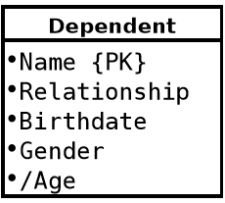

Dependent
EmployeeId | DependentName | Relationship | Birthdate | gender

To convert a weak entity you include the primary key in the relational model for that entity and use it and the primary key for the weak entity as a composite key.

1.g. 1-1 Relationship – Manages

Participants: Manager, Factory.

Attributes of Relationship: StartDate.

Description: An employee manages only one factory and a factory has only one manager.

Participation: Employee and Factory have total participation. This means that each factory must have a manager and a manager must manage a factory.

UML:

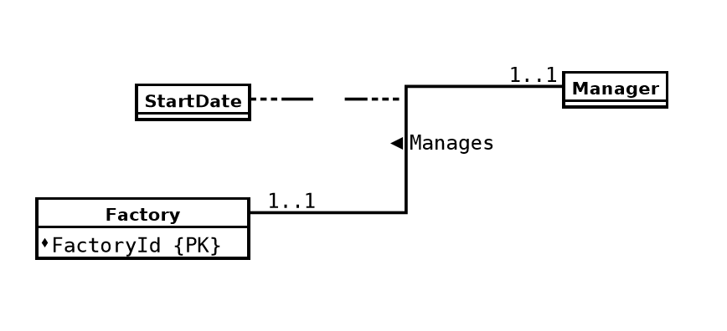
Factory Untertakes 1..*
FactoryId | F_Name | Budget | noOfBuilding | Mgr_Id | StartDate | ProjectId

